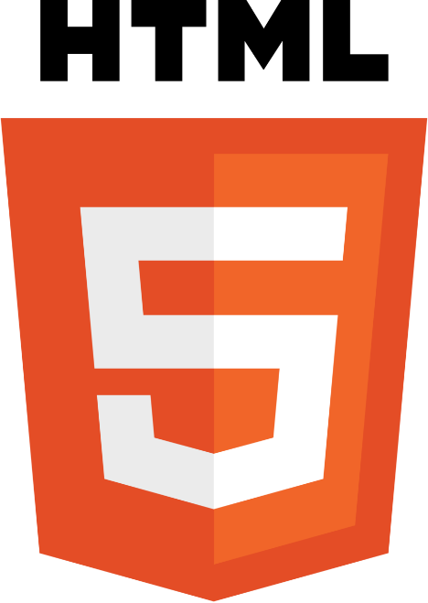

**HTML (Hyper Text Markup Language) – A Comprehensive Definition**

HTML (HyperText Markup Language) is the foundational language used to create and structure web pages on the internet. It provides a standardized way to organize content, ensuring that web browsers like Google Chrome, Mozilla Firefox, and Microsoft Edge can interpret and display it correctly. HTML is not a programming language but a markup language that structures web content through a system of elements and tags.

**Key Features of HTML**

1. **Tag-Based Markup Language**  
   HTML uses tags enclosed in angle brackets (<>) to define elements. Most tags have an opening (<tag>) and a closing (</tag>) counterpart, except for self-closing tags like <img> and <br>.
2. **Hyperlinks and Navigation**  
   The <a> tag allows users to navigate between different web pages using hyperlinks.
3. **Multimedia Integration**  
   HTML supports embedding images (<img>), audio (<audio>), and video (<video>) to enhance user experience.
4. **Forms and User Input**  
   The <form> tag, combined with elements like <input>, <textarea>, and <button>, enables user interactions such as login forms, search bars, and feedback submissions.
5. **Tables and Lists**  
   HTML provides <table> for organizing data in rows and columns, and <ul> or <ol> for creating bullet or numbered lists.

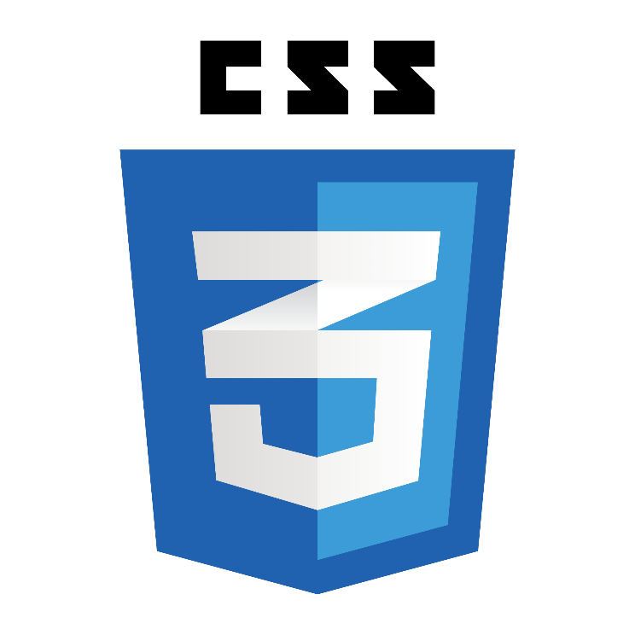

**CSS (Cascading Style Sheets) – A Comprehensive Definition**

CSS (Cascading Style Sheets) is a stylesheet language used to describe the presentation and layout of web pages. It controls how HTML elements appear on the screen, including aspects like colors, fonts, spacing, positioning, and animations. By separating content (HTML) from design (CSS), it enhances web development efficiency, making websites visually appealing and user-friendly.

**The Role of CSS in Web Development**

CSS plays a critical role in modern web design by allowing developers to:

* Control the look and feel of web pages.
* Apply consistent styling across multiple pages.
* Improve website responsiveness for different screen sizes.
* Enhance user experience with animations and transitions.

CSS works alongside HTML and JavaScript to build dynamic, attractive websites.

**CSS3 and Its Advancements**

CSS3 introduced modern features such as:

* **New Selectors** (nth-child, not())
* **Flexbox and Grid Layouts**
* **Custom Fonts (@font-face)**
* **Improved Animation Capabilities**
* 

**JavaScript (JS) – A Comprehensive Definition**

JavaScript (JS) is a high-level, interpreted programming language that enables dynamic and interactive web content. It is one of the core technologies of web development, alongside **HTML (HyperText Markup Language)** and **CSS (Cascading Style Sheets)**. While HTML structures a webpage and CSS styles it, JavaScript adds interactivity, making it more engaging for users.

Initially designed for web browsers, JavaScript has evolved into a versatile language that powers web applications, mobile apps, server-side applications (via **Node.js**), and even game development.

**The Role of JavaScript in Web Development**

JavaScript enhances webpages by enabling:

* **Interactivity** – Animations, dropdown menus, modals, and form validations.
* **Dynamic Content Updates** – Without reloading the page, using technologies like **AJAX** and **Fetch API**.
* **Event Handling** – Detecting and responding to user actions like clicks and keypresses.
* **DOM Manipulation** – Changing webpage content dynamically using the **Document Object Model (DOM)**.
* **Browser API Integration** – Accessing storage, geolocation, notifications, and more.



**PHP (Hypertext Preprocessor) – A Comprehensive Definition**

PHP (Hypertext Preprocessor) is a widely used, open-source server-side scripting language designed primarily for web development. It enables dynamic content creation, database interactions, and server-side functionalities, making it a key component in web applications. PHP scripts are executed on the server, and the resulting HTML is sent to the client’s browser.

PHP was originally created by Rasmus Lerdorf in 1994 and has since evolved into a powerful language with extensive support for databases, security, and scalability. It is commonly used in combination with **HTML, CSS, JavaScript, and MySQL** to develop full-fledged web applications.

**The Role of PHP in Web Development**

PHP is an essential backend language used for:

* **Generating Dynamic Web Pages** – Creating personalized content for users.
* **Handling Form Data** – Processing user inputs securely.
* **Database Connectivity** – Storing and retrieving data using databases like MySQL, PostgreSQL, and MongoDB.
* **User Authentication** – Managing logins, sessions, and security features.
* **File Handling** – Uploading and managing files on the server.
* **API Development** – Creating RESTful APIs to integrate with front-end frameworks like React or Vue.js.

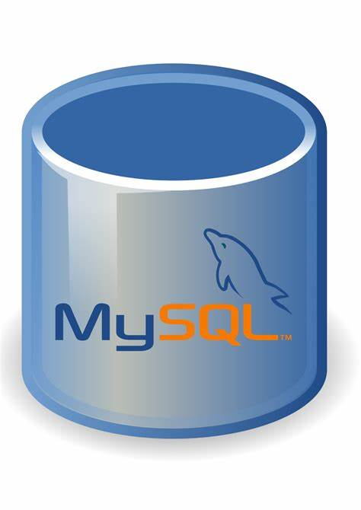

**MySQLi (MySQL Improved) – A Comprehensive Definition**

**MySQLi (MySQL Improved)** is an extension of PHP that provides an enhanced interface for interacting with MySQL databases. It was introduced in **PHP 5.0** as an improvement over the older **MySQL extension**, offering better performance, security, and support for **prepared statements**, **transactions**, and **object-oriented programming (OOP)**.

Developers use MySQLi to **connect, query, and manipulate** databases efficiently. It is one of the two main options for database interaction in PHP, with the other being **PDO (PHP Data Objects)**. MySQLi is **MySQL-specific**, whereas PDO supports multiple database types.

**Key Features of MySQLi**

MySQLi offers several advantages over the old MySQL extension:

1. **Supports Both Procedural and Object-Oriented Approaches** – Allows developers to use the style they prefer.
2. **Prepared Statements** – Enhances security by preventing **SQL injection**.
3. **Transactions and Rollbacks** – Ensures data integrity during complex operations.
4. **Multiple Query Execution** – Supports batch queries for efficiency.
5. **Enhanced Debugging Capabilities** – Provides detailed error messages.

**Connecting to a MySQL Database Using MySQLi**

There are **two ways** to use MySQLi in PHP:

* **Procedural Style**
* **Object-Oriented Style**